DNA Bases
DNA molecule has a twisted double strand (double helix) shape. It looks a bit like a ladder.
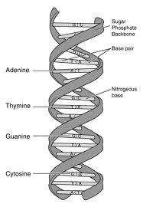
The sides of the ladder are made out of Phosphate(P) and sugar(S) moleclues. This is called the sugar phosphate backbone.
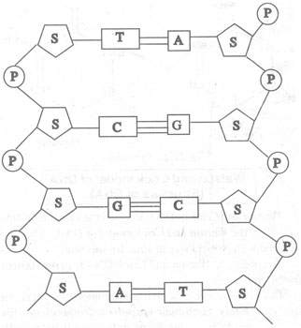
The steps of the ladder are made of special chemicals called nitrogen bases. The nitrogen bases come in pairs called nitrogen base pairs.
Adenine bases (A) always join to Thymine( T) bases.
Thymine bases (T) always join to Adenine(A) bases.
Cytosine bases always join to Guanine(G ) bases.
Guanine bases always join to Cytosine (C) bases.
This is called complimentary base pairing.
Building a DNA Molecule
- On the large A3 sheet of paper:
Colour all of the letter A and T Parts red.
Colour all of the letter C and G parts Green.
- On the smaller A4 sheet:
Colour all of the letter A and T Parts red.
Colour all of the letter C and G parts Green.
- Cut out all of the letter Ts from the small A4 sheet. Stick the letter Ts that you have cut out so that they join with the letter As on the big A3 sheet.
- Cut out all of the letter As from the small A4 sheet. Stick the letter As that you have cut out so that they join with the letter Ts on the big A3 sheet.
- Cut out all of the letter Cs from the small A4 sheet. Stick the letter Cs that you have cut out so that they join with the letter Gs on the big A3 sheet.
- Cut out all of the letter Gs from the small A4 sheet. Stick the letter Gs that you have cut out so that they join with the letter Cs on the big A3 sheet.
- Now cut out all of the letter S form the smaller A4 sheet. Glue them onto the A3 sheet.
- Cut out all of the letter Ps from the smaller A4 sheet. Glue them to the A3 sheet.

